

**Payroll System**

**POSEgg009**

HUEVO – MARCH 2017

|  |  |  |
| --- | --- | --- |
| **SCRUM TEAM** | **SPRINT NAME AND DURATION** | **CHANGES** |
| Huevo | POSEgg009  4/March/17  to  18/March/17 | * **Generate Payroll Page** |

**POSEgg006**

This story includes the creation of Generate Payroll page. The Generate Payroll Page can view the salary of the employees. The team are creating Generate Payroll page were users can access view and compute for the salary of employees.

1. Range date of the Payroll

Step1: Go to Date From

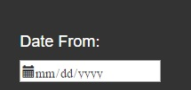

Step2: Click Date picker dropdown button, you can now pick a date.

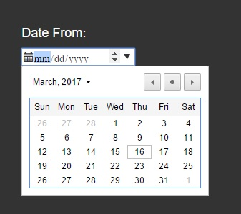

Step3: Go to Date To

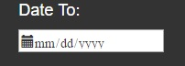

Step4: Click Date picker dropdown button, you can now pick a date.

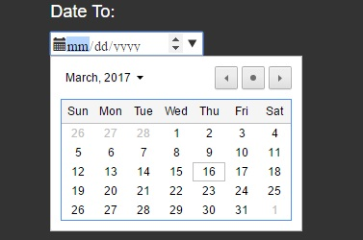

Step5: After picking date for the range dates, Click the button Generate Payroll to compute the salary of the employees.

1. Generate Payroll Button

Step1: Click the Generate Payroll Button

